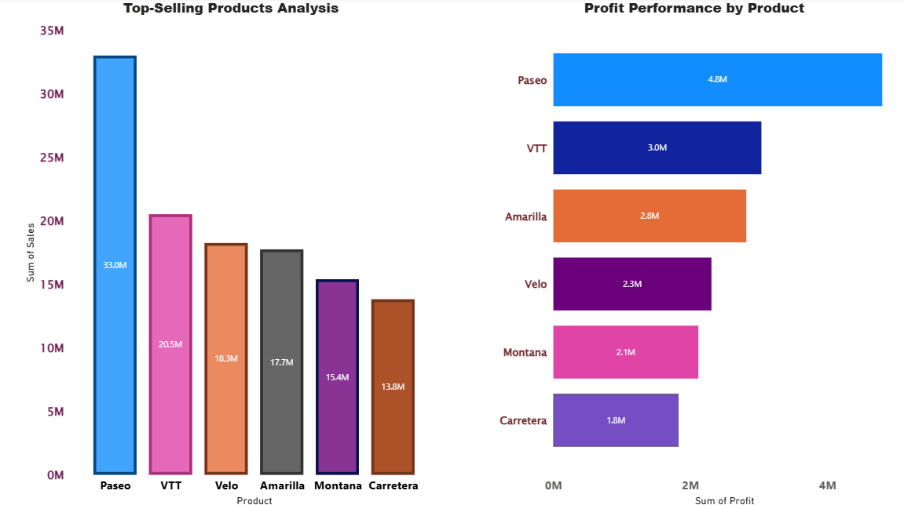

**Product Sales & Profit Analysis – Insights**

**1. Sales Performance by Product (Left Chart)**

* **Paseo** leads significantly with **33.0M in sales**, outperforming all other products by a large margin.
* **VTT (20.5M)**, **Velo (18.3M)**, and **Amarilla (17.7M)** form the mid-performing group with relatively balanced contributions.
* **Montana (15.4M)** and **Carretera (13.8M)** remain the lowest contributors to overall revenue.
* The sales gap between Paseo and Carretera is nearly **20M**, highlighting a high dependency on a single product.

**2. Profit Performance by Product (Right Chart)**

* **Paseo** again dominates with the highest profit of **4.8M**, confirming its overall profitability strength.
* **VTT (3.0M)** and **Amarilla (2.8M)** deliver healthy profit margins relative to their sales volume.
* **Velo (2.3M)** and **Montana (2.1M)** generate moderate profits but underperform compared to peers with similar sales levels.
* **Carretera** is the weakest performer with only **1.8M in profit**, mirroring its low sales contribution.

**3. Comparative Insights**

* **Market Leader:** Paseo is the undisputed leader in both sales and profit, driving the largest share of business performance.
* **Profitability Efficiency:** VTT demonstrates stronger profitability than Velo despite similar sales, suggesting better cost management or pricing strategy.
* **Lagging Products:** Montana and Carretera consistently rank lowest in both metrics, indicating low demand and reduced profitability potential.
* **Business Implications:**
  + Prioritize **scaling Paseo** further to capitalize on its dominance.
  + Conduct a **margin analysis for Velo** to identify profit leakage.
  + Reevaluate **Montana and Carretera’s viability** options may include repositioning, promotional support or discontinuation.